**ProP**

Course: **ProP**

Group: **12**  
Names: **Subhi Hamidi  
 Ryan Hermelijn  
 Mohammad Baghban Haghighi  
 Gael Shema**

Date: **7-9-2018**

Teacher: **Matthijs Kuiper**

Version: **1.1**

Table of Contents

Project Statement 3

Formal client 3

Project leader 3

Initial situation 3

Problem description 4

Project goal 4

Project deliverables and non-deliverables 4

Deliverables 4

Non-deliverables 5

Project constraints 5

Project risks 6

Project phasing 8

Phase 1: Initiation 9

Phase 2: Definition 10

Phase 3: Design 11

Phase 4: Build 12

Phase 5: Test 13

Phase 6: Deployment 13

# Project Statement

In this chapter we will describe how our project started and what the end goals are. Further the following topics will be described: the client, the project leader, the initial situation, the problem description, the end goal of our project, the project’s deliverables and non-deliverables, the project constraints and as last the project risks.

## Formal client

Mr. Henning, Frank F.L, is a teacher at Fontys University of applied sciences, the English stream department. Fontys University in the School of Information and Communication Technology (ICT), which is located in Eindhoven.

Mr.Henning is the organizer of a 3-days events which is called: Highlands Halloween Festival

**Contact Information:**

Phone Number: +(316) 12208921

E-mail: f.henning@fontys.nl

## Project leader

The team leader is Mr. Baghban who has experience in software development and project management. Working alongside is:

Mr. Hamidi, Mr. Gael and Mr. Hermelijn.

**Contact Information:**

Name: Mohammad Reza Baghban

Phone: (+31) 685264262

E-mail: [Mrbhmr@gmail.com](mailto:Mrbhmr@gmail.com)

## Initial situation

The company(XX) needs a software solution in order to manage its events and that is due to the uncontrollability of the events without a perfect software solution to keep track of everything is going on in the event.

The event is named “Highlands Halloween Festival”, a Halloween Spooktacular; Eat, play and be scary. Throwing a big Halloween event is a great opportunity for students and student organizations to get involved, expand their friend network and create wonderful memories.

Offer fun activities such as games, dancing, a photo booth, haunted houses, caricature artists and of course a costume contest (with prizes for best costume!)

The event needs a ghostly playlist, or better yet, one of the musical ensembles (instrumental or choir) to dress and play in costumes while attendees enjoy food, sweets, hot chocolate, drinks and camp as well.

Most importantly, the company would like to make money out of the event in every possible way, Therefore, the project team is required to come up with a plan that contains details about creating the applications. The applications should be handed within **4** months.

## Problem description

the commercial company, they want to make profit. Money can originate from: visitors purchasing tickets(25000 tickets) to enter the event, buying food and loaning products (such as photo

cameras,etc..). The event will last more than one day, people can rent a camping spot(there are 1000 spots). So the camping will be required to have its own reservation application. Banks will place ATM machines on the terrain which allow visitors(6000 visitors) to deposit money on their account therefore we also need an application to check atm information. Because the events started to attract more visitors, Last, it should be possible for visitors to deposit money to their account in two ways: before the event through the website, and on the event, by ATM machines which a bank has provided.

it has become impossible to manage them without a proper software solution.

## Project goal

This project’s goals are:

* Make a proper software solution to manage the event fully
* Make a considerable profit from selling tickets and promoting the event online and offline

## Project deliverables and non-deliverables

### Deliverables

* Agendas and minutes of every meeting with client
* A chosen name and designed logo for our team
* A project plan
* A Setup document
* A website - Wireframe
* A website (static part)
* A clear database design (ERD) in MySQL modelling application
* A process report
* Agendas and minutes of every meeting
* A universal C# application to can be utilized in all following situations:
  + Entrance gate of event
  + Entrance of camping site
  + Stores
  + Stand where visitors can loan materials
  + Check-out spot where visitors leaves the event
  + Managing office to perform following tasks:
    - check the status of the event
    - Convert the information in the transaction-log-file to the database
* A fully functional Website
* A presentation about project
* Process Report

### Non-deliverables

* User guide; Although providing a detailed user manual will enhance user experience, time is needed for providing such a documents will exceed the time constraint that was determined for the project implementation.
* The source code of the backend server and front-end design of website.
* The source code of designed universal C# application that want to be used during event
* The communication proof of team members.
* Maintenance after the final evaluation would be done by client

## Project constraints

* **Time**

The duration for the project is 4 months.

* **Budget**

The total allocated budget for this project is: ***50000€*** euros. This will be divided into:

* 1400 man hours at a rate of 28 euros per hour.
* 4000€ for software & hardware related costs.
* 4000€ for any possible risk
* 2000€ for marketing related costs
* **App Language**

The language of the application will be in English due to the target audience of the client.

* **Programming Language**

The programming language that we will use are:  
· C# for the desktop variant  
· SQL for the database  
. HTML, Php, JavaScript and CSS for the website  
  
We will use the pre-mentioned programming languages as we already have access to Visual Studio (IDE) as for the C# and there is no specific tool for the website.

* **Database**

We will make use of MySQL Developer to design a data model.

## Project risks

|  |  |  |  |  |
| --- | --- | --- | --- | --- |
| **Risks** | **Probability** | **Impact on the project** | **Prevention** | **Action** |
| 1.The program doesn’t work properly | Low | High | Hire a team of tester to test the program and find as many bugs as possible. | Try to identify the error and fix the bug as soon as possible before delivering the first version which has to meet the client requirements. |
| 2. incapability to finish on time | Low | High | Follow the project phasing and schedule as close as possible and have bi-weekly meeting. | Negotiate to push the deadline back  Try to work before clock. |
| **3.** The client doesn’t satisfy with the product | Medium | High | Make sure that the product meets all the requirements and also make sure that the developer team understands what need to be done. | Arrange a meeting with the client. Then, modify the application to meet the requirements. |
| **Limited resources to complete project** | Low | High | Create a work breakdown structure and specify where our funds will be going towards. | Negotiate with the client for a higher budget or sacrifice the quality of the product to match resources. |

# 

# 

# 

# 

# 

# 

# Project phasing

In this second chapter, it is described how our team will work on this project step by step, milestone by milestone. In the visual below the phases of our project with activities and milestones and their dependencies to each other are all represented where you can see an overview our activities, the phases they occur in and the milestones we’ve decided on. This project will last 20 weeks to be completed. The critical path is shown with bright green border on lasting activities in building phase

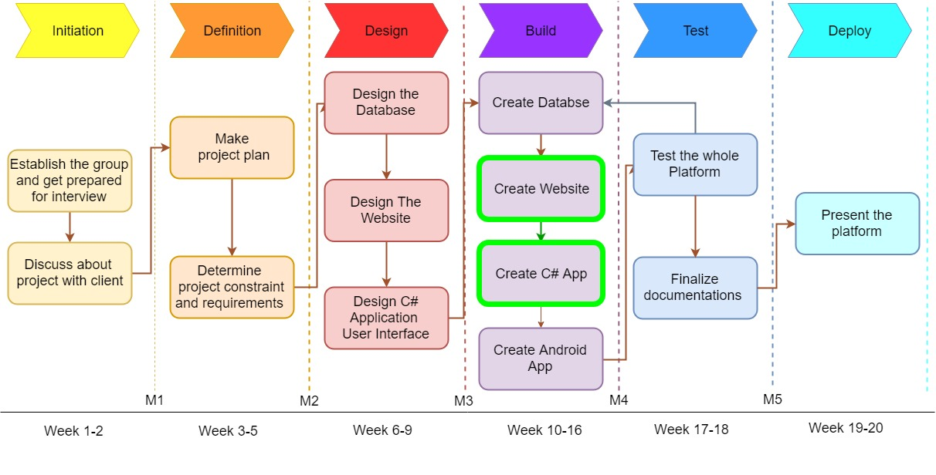

## Phase 1: Initiation

During this first phase, the project’s objective is identified.

Activity: Establish the group and get prepared for the interview:

Tasks for this activity are:

* Establish group and choose participants
* Choose group leader of team
* Choose a name for group
* Design a logo for group
* Create a time schedule for group meeting
* Evaluate provided information upon project
* Make Question for interview with client

Estimated duration is 1 week and 32 man hours

Activity: Discuss about the project with the client

Tasks for this activity are:

* Arrange meeting with the client
* Interviewing the client and share questions with him
* Discuss the current situation, the problems, and the desired end results.
* Define each task for each team member (project leader, specialist, etc.).
* Evaluating similar solutions on the market
* Create a mind map
* Define the project phasing

Estimated duration is 1 week and 32 man hours.

Deliverables for milestone M1 are:

* Detailed work division among team members
* A name and logo for the group
* The project plan
* Mindmap

## 

## 

## 

## 

## Phase 2: Definition

During this second phase, we will define the needed requirements for the remaining phases.

Activity: Make the first draft of Project Plan

Tasks for this activity are:

* Design outline and structure of Project Plan for Client
* Explain the initial situation
* Provide problem description
* Determine (non)deliverables
* Determine Constraint and Risks
* Scheduling the outline of project phasing

Estimated duration: 2 weeks and 64 Hours

Activity: Discuss the constraints and requirements of the apps and website.

Tasks for this activity are:

* Make a choice on which programming language we’re going to be used to make the apps.
* Make a choice on which framework we’re going to use for the website.
* Make a choice on which modeling tool we’re going to use for the data model of the database.
* Make some investigation upon which means of identification should be chosen
* Provide first draft of Setup Document
* Revise and provide Final version of Project Plan

Estimated duration is 1 weeks and 32 man hours.

Deliverables for milestone M2 are:

* The programming language that’s going to be used for the apps.
* The framework that’s going to be used for the website.
* The modeling tool we’re going to use for the data model of the database.
* Final version of project plan
* Draft of Setup Document

## Phase 3: Design

During this third phase, we have 2 major activities: Making the design of the website and making the design of the user interfaces of the C# applications. For these activities, the tasks are described below.

Activity: Design the website

Tasks for this activity are:

* Look at websites which have the same use case for inspiration
* Look at website templates for inspiration.
* Create the wireframe of the website

Estimated duration is 1 week and 32 man hours.

Activity: Design the user interfaces for the C# applications

Tasks for this activity are:

* Think about the requirements which need for the user interface.
* Make an initial draft of the user interface
* Once the design has be finalized, different iterations will be made from it with each their own exclusivity.
* Write pseudocode to make the next phase easier

Estimated duration is 1 week and 32 man hours.

Activity: Design the database

Tasks for this activity are:

* Make the tables for the database
* use normalization to convert them into an ERD.
* Convert the ERD into a data model
* Make a database design based on the data model

Estimated duration is 1 weeks and 32 man hours

Deliverables for milestone M3 are:

* The website’s design
* The C# app’s design
* The database’s data model
* Setup Document

## Phase 4: Build

For this next phase we will describe how functionality will be added to the items that were mentioned in the design phase.

Activity: Create the database

Task for this activity is:

* Recheck the structure of database
* Transfer the data model into the database design
* Create actual database using MySQL

Estimated duration is 5 days and 15 man hours

Activity: Create the website

Tasks for this activity are:

* Create the web structure using HTML
* Create the website’s style using CSS
* Implement the required JavaScript
* Create a login/register system using PHP
* Connect website to the database

Estimated duration is 3 weeks and 96 man hours

Activity: Create the C# application

Tasks for this activity are:

* Recreate the pseudocode in working code
* Create test applications of each of the applications required
* Create a connection between the database and the applications
* Place all the applications in a tabular layout

Estimated duration is 3 weeks and 96 man hours

Activity: Create simple Android Application for taking simple log

* Create an android application for event organizer that can take retrieve the whole revenue of the event in simple chart(s)

Estimated duration 1 Week and 32 Hours

Deliverables for milestone M4 are:

* The website
* The database
* The C# applications
* Simple Android Application

## Phase 5: Test

In this phase we will test our deliverables from phase 4 in order to see if they work properly or not. If they do not work correctly, we will be forced to go back to the 4th phase in order to correct our mistake(s).

Activity: Test the deliverables from phase 4

Tasks for this activity are:

* Research methods that would prove beneficial in testing the phase 4 deliverables
* Divide the team in 3 groups that will conduct the tests
* Record all results in a test report

Estimated duration in 1 weeks and 32 man hours

Activity: Finalizing project documentation

Tasks for the activity are:

* Finalize test plan
* Finalize test report
* Finish process report

Estimated duration in 1 Week and 32

Deliverables for milestone M5 are:

* Test plan
* Test report
* Process Report

## Phase 6: Deployment

In this final phase we will present the deliverables from phase 4 tested. We have to give a presentation about the deliverables and incorporate a demo in the presentation itself.

Activity: Final stretch

Tasks for this activity are:

* Prepare the demo for the client
* Prepare the presentation

Estimated duration is 1 week and 10 man hours

Deliverables for milestone M6 are:

* The website
* The database
* The C# applications
* Presentation